3D Weather in the Classroom

**Southern Hemisphere Polar Jet**

**1.Overview**

The polar jet is described as narrow bands of strong winds that flow west to east in both the northern and southern hemisphere. This jet stream divides the cooler air within the Polar cell from the warmer air within the Ferrel cell.

Revisiting the concept of global circulation, if the earth was not rotating, the default circulation pattern would be warm air from the equator flowing poleward (both north and south poles), but with a rotating earth, the jet stream has gained momentum causing the west to east direction of flow, but the sinusoidal pattern of the jet streams is a product of the equatorial air wanting to flow poleward. This sinusoidal pattern can be described as the flow of direction shifting to a more northward direction to a southward direction as it meanders around the globe. Both the northern hemisphere and southern hemisphere jet streams portray this pattern.

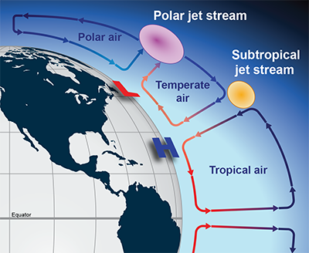

Figure 1. The three global circulation cells and the polar and subtropical jet streams.

These cells are a product of a rotating earth where cooler air is contained within the Polar cells and the warmer air is contained within the Ferrel cell, and the strong winds of the jet stream are a product of the temperature gradient between these cells. The stronger the temperature gradient between these cells, the stronger the upper-level winds of the jet stream will be. Although the northern hemisphere is most commonly discussed in the United States as being a major factor influencing our weather year-round, the southern hemisphere polar jet has similar characteristics, but slight differences influenced by landmasses, larger areas of open ocean, and weaker temperature gradients.

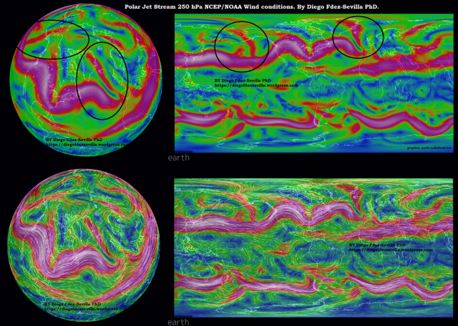

Figure 2. The 250 mb wind conditions of the Polar Jet stream in the Northern and Southern Hemispheres.

The southern hemisphere jet stream shown can be described as having a more laminar flow (Figure 2). Laminar flow means that the direction of flow is more parallel and less sinusoidal as seen in the northern hemisphere. The northern hemisphere contains more land masses influencing the jet stream’s direction of flow. Landmasses contain a lower specific heat than open bodies of water, therefore, the temperature gradients vary more than they do in the southern hemisphere. The southern hemisphere polar jet has less interruptions from landmasses and varying temperatures, therefore, the west to east direction of flow is more constant being laminar and less sinusoidal.

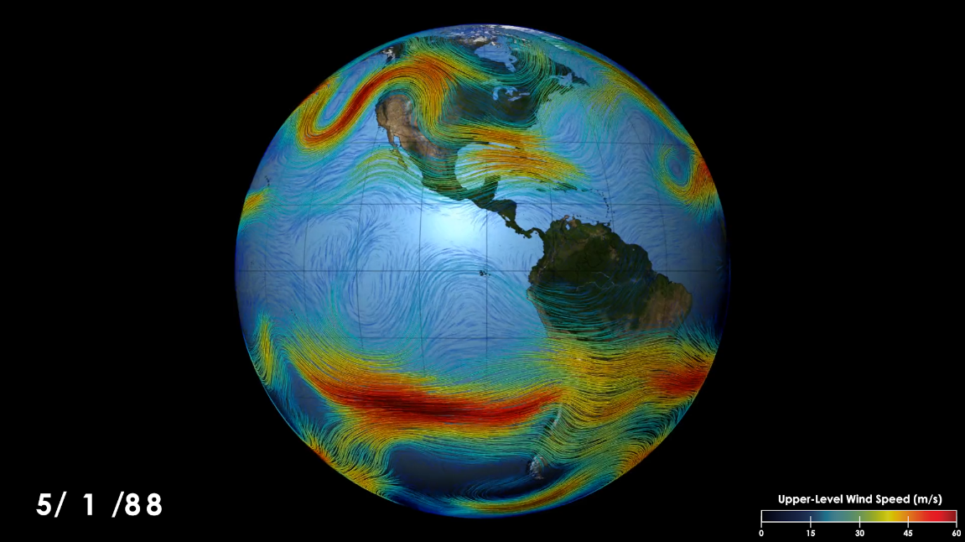

Figure 3. Upper-level wind speeds of the polar jet in both the Northern and Southern Hemisphere from May 1st, 1988.

The disruption of flow can be seen over the southern portions of South America where a sinusoidal pattern is visible unlike over the open ocean where the flow of direction is visibly laminar (Figure 3). This disruption is due to the landmass disrupting the flow. The disruption of flow is obvious when observing the jet stream in the Northern Hemisphere.

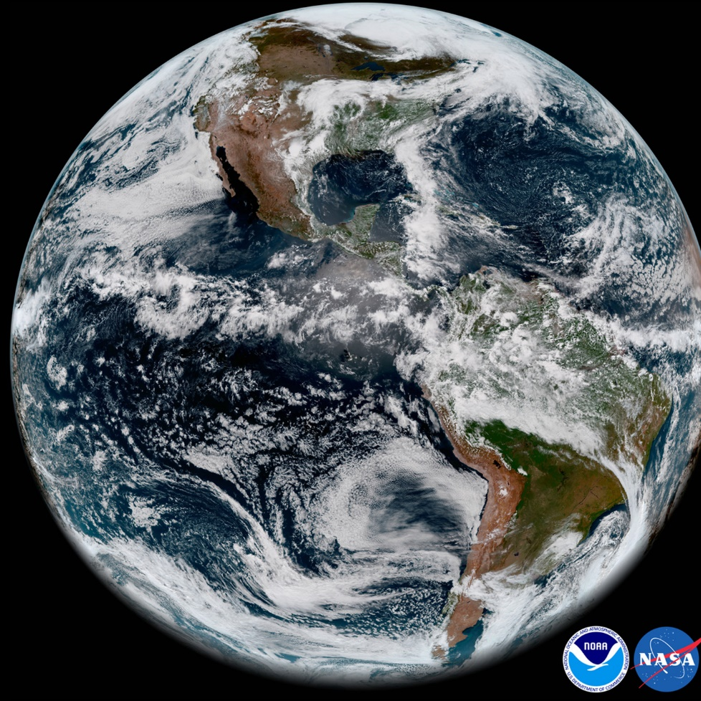

Figure 4. Satellite imagery of cloud formation over the Western Hemisphere.

When observing visible satellite imagery, the cloud formation influenced by the jet streams hints at the flow of direction (Figure 4). In the northern hemisphere, there is more cloud cover and visible eddies that are the effect of the sinusoidal pattern of the jet stream. In the southern hemisphere, the is cloud formation along the jet stream, but not as many cyclones that are a product of the flow.

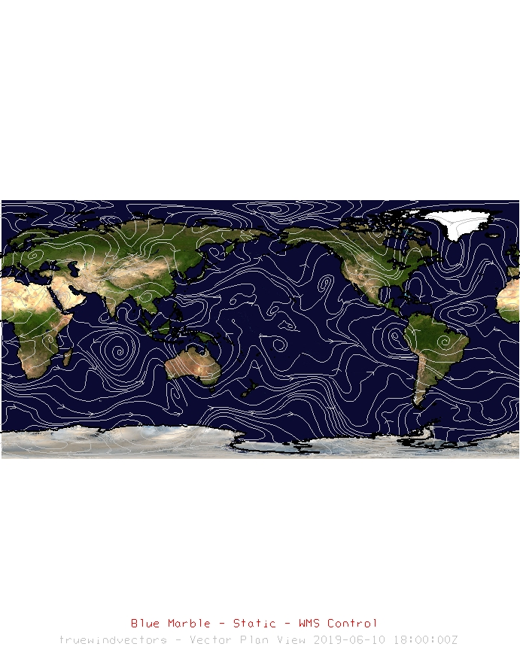

Figure 5. IDV image of 300 mb streamlines from June 10, 2019 18 UTC.

The direction of flow along the boundary between the cells in the northern hemisphere varies a lot more than that of the southern hemisphere (Figure 5). This is particularly evident when observing the areas over land masses. In areas over open oceans, you can see the more laminar flow. The Laminar flow is particularly evident in the southern Pacific Ocean.

**2. IDV Project**

Project filename: “SouthernHemispherePolarJet.xidv”

* Project data:
  + Filename:“gfsanl_4_20190610_1800_000.grb2”
  + Global Forecast System Model on June 10, 2019 @ 1800 UTC
  + File retrieved from NOAA operational model page for select levels and variables:
    - [NOMADS-NOAA Operational Model Archive and Distribution System](https://nomads.ncep.noaa.gov/)
* Displays:
  + Maps
    - World country outlines.
    - Blue Marble Background
* Flow
  + Streamlines at 300 mb

Features to note:

* Figure 5. Streamlines show the general direction of flow for both the northern and southern hemisphere polar jets.
  + In the northern Hemisphere, the flow is disrupted by land masses and a lack of open water. This flow is also referred to as the westerlies in the Northern Hemisphere and influence North American weather year-round.
  + In the Southern Hemisphere, the flow is more laminar and parallel rather than meandering like the flow in the Northern Hemisphere. This is due to open ocean. Although, if you notice the flow around land, it has some disruptions.

**3. Knowledge Requirements**

Module 5-2: Pressure and Wind at Different Atmospheric Levels

Module 1-1: Temperature

**4. Knowledge Test**

Question 1: The jet stream is a product of?

* A: Fast wind speeds due to temperature gradient between the Polar and Ferrel cells
* B: high moisture
* C: rotating earth
* **D: Both A and C**

Question 2: How would you describe the polar jet stream’s pattern in the Northern Hemisphere?

* A: meanders more than the southern hemisphere polar jet
* B: sinusoidal
* C: disrupted by landmasses
* **D: All of the above**

Question 2: How would you describe the polar jet stream’s pattern in the southern hemisphere?

* A: laminar
* B: less land mass disruptions than the northern hemisphere
* C: less meandering
* **D: All of the above**

Question 3: The ________ the temperature gradient between the cells, the ________ the upper-level winds will be.

* A: stronger weaker
* B: weaker, stronger
* **C: stronger, stronger**
* D: weaker, weaker

Question 4: Why is the Southern Hemisphere Polar Jet different than the Northern hemisphere polar jet?

* A: landmasses
* B: larger areas of open ocean
* C: weaker temperature gradients.
* **D: All of the above**

Question 5: Define laminar flow.

* A: more sinusoidal, less parallel
* B: more parallel, less sinusoidal
* C: no disruptions in flow
* **D: Both B and C**

Question 6: The change is direction of flow varies more in the ________.

* **A: northern hemisphere**
* B: southern hemisphere

Question 7: The southern hemisphere polar jet is disrupted by what?

* A: Africa
* B: Australia
* C: South America
* **D: All of the above**

Question 8: The northern hemisphere polar jet is NOT only by what?

* A: northern Atlantic
* B: northern Pacific
* **C: Both A and C**

Question 9: Why do the jet streams tend to meander over landmasses?

* A: the land gets in the way of wind
* **B: temperature gradients**
* C: faster winds
* D: momentum

Question 10: Where is laminar flow most prominent in the southern Hemisphere?

* A: the south Pacific
* B: South Atlantic
* C: Southern Ocean
* **D: All of the above**